All Foundation and CPD courses can be found on the online course booking system.
The Club covers the costs of courses. Please Book, Pay, Attend and then, on completion, send receipt to Mike Courtness (mike.courtness@ntlworld.com) and notification to Stephen Wickens (Camberleyccc@gmail.com).
Registering for a Course/Award
- Identify a course by using the course search facility http://www.englandrugby.com/my-rugby/courses/
- Log-in to Rugby First – or simply register if you have not already done so.
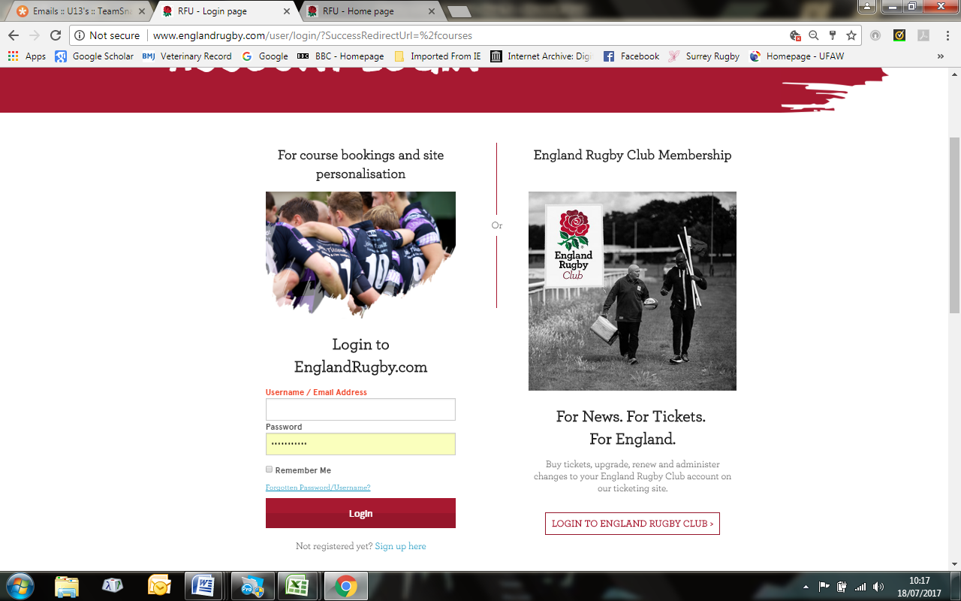
If you know you Rugby First details log in (not essential), if not just click Register
You could recover your password if you believe you are registered on Rugby First and have forgotten it.

- Select Course Type (Referee, Coaching, Volunteer), Course Name, or enter your post code – press search. 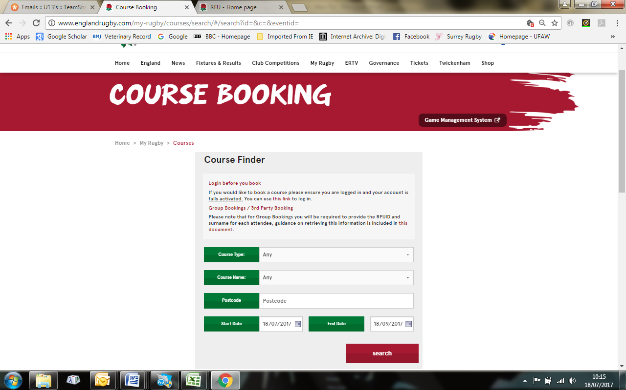

- A list of courses will appear – select course you wish to apply for.
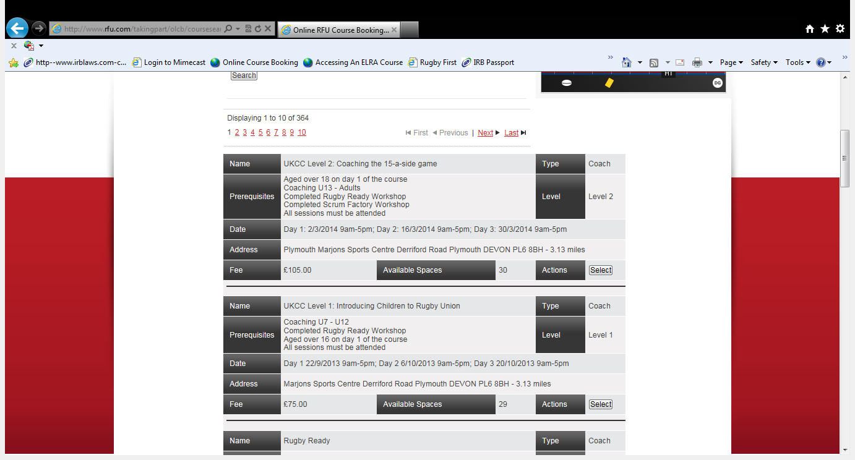
- Tick the appropriate check boxes to confirm you meet the pre-requisite course criteria, all criteria will be subsequently checked.
- You will then be asked to either checkout or search for another course. Click checkout
- Make payment on-line (Payment will be required on registering for a place). Please note this does not automatically guarantee a place on the course.
- Successful applicants will be informed within 7 days of acceptance on a course.
- Unsuccessful applicants will be informed and payment will be refunded via Twickenham.
- Award courses will only accept individual applications.

